OOPS Concepts:-

Encapsulation :- Wrapping data members & its functions in to a single unit. We achieve in java using Class. In class we have methods and variables, these are referred by object of a class.

If Creating a Class with Private variables & these Private Variables can be Accessed using Public setters & getters methods

Setter methods are used to set values for private variables(Class Level) of a class.

Setter method Return Type will be always void.

Getter Method return type will be always the return type of its variable

Q)What are OOPS Concepts? How did u achieved in u r project?

A) in java we have 4 types of oops concepts

Q) What is encapsulation? How did u achieved in u r project?

Encapsulation :- Wrapping data members & its functions in to a single unit. We achieve in java using Class. In class we have methods and variables, these are referred by object of a class.

1. Abstraction :-

Hiding the Implementation of the functionality. It Tells how it is works & but it doesn’t tell how it was Implemented.

Ex;- clicking on login button(we don’t know how it is validating the Authentication)

Ex:- clicking on Submit button(we don’t know how all the data is saved & submitted in the backend)

This is Achieved by Interfaces & Abstract Classes.

100% Abstraction can be Achieved with Interface

100% Abstraction cannot be achieved with Abstract Class because it might/can contain defined methods because of which 100% Abstraction is not possible

|  |  |
| --- | --- |
| Abstract Class | Interface |
| It Contains Abstract Methods & Defined Methods & Constants | It contains only Abstract Methods & Constants(public static final) |
| Abstract Keyword has to applied at class level & Method Level for Abstract methods | Abstract Keyword is optional at Interface level & method level because JVM will anyways provide . |
| Abstract class can contain Constructor but it will be used by its subclasses | Interface cannot contain Constructor because it will give compilation error if we add Constructor |
| Class &Abstract Class will not participate in Multiple Inheritance | Interface can be used in multiple Inheritance. |
|  |  |
|  |  |
|  |  |

Similarity

object Cannot be created for Both Abstract class & Interface.

Abstract class objects can be create by using its sub classes.

Interface methods are accessed by using its sub class objects.

Q) What is abstraction? How did u achieved in u r project?

Hiding the Implementation of the functionality. It Tells how it is works & but it doesn’t tell how it was Implemented. We can use this feature an interfaces and abstract classes with abstract methods . by looking at this abstract methods we don’t know how it was implemented, because these methods are overridden in it’s sub classes.

Q) What is difference b/w interfaces and abstract classes?

Refer the above table.

Q) how can u solve diamond problem in inheritance?

Using interfaces. see the hybrid inheritance in diagram .

Inheritance :- Inheritang the Properties and behaviours(variables and methods) from Parent to its children

1. InHeritance :- Inheriting the variables& methods from SuperClass to its SubClasses(Parent to Child)

Private methods & private variables cannot be accessed/Visible in SubClasses.

Inheritance can be achieved through **extends** keyword between classes(A,B)& Interfaces(I1,I2)

Ex:- **Class A extends B**

Interface I1 extends I2

Class A can Implement Interface I1

Ex:- Class A Implements I1

Interface I1 cannot Implement or Extend Class A

Interface I1 implements class A (Not Possible)

**Single Inheritance:-**

We can Create objects of SuperClass with SuperClass Reference so that we can access all the Public methods in SuperClass.

We can Create objects of SubClass with SubClass Reference so that we can access all the Public methods in SubClass & SuperClass

If we Create objects of SubClass with SuperClass Reference then we can access all the Public methods of SuperClass But we will not be able to access methods from Sub Class.

**Multiple inheritance**  in the below diagram A and B are interfaces C is sub class of A and B.

**Note**: If a class (C) implements an interface(I) it has to override all the methods of interface.

if we don’t override any method of the interface It will gives compilation error.

If an abstract class (C) implements an interface(I) overriding the methods of interface is optional.

**Hybrid inheritance** is the combination of more than one inheritances

In Hybrid Inheritance, A,B,C should be Interfaces because if A is Class B & C cannot implement class A.

If a Class A extends ClassB and implements Interfaces I1,I2 we should write the syntax as below:-

Class A extends B implements I1,I2

Class A implements I1 extends B ------not possible throws compilation error

Q) What is inheritance? How did u achieved in u r project?

Inheriting the variables& methods from SuperClass to its SubClasses(Parent to Child)

In our project generally we extends some abstract classes or interfaces

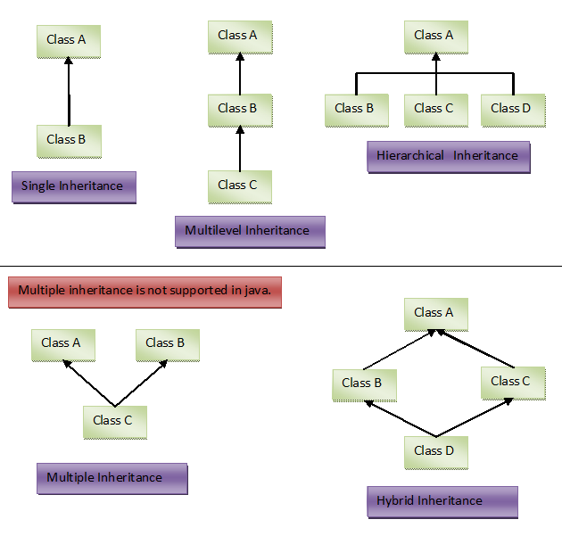

4.Polymorphism :-

Same Action Can be performed in multiple ways

We can achieve this feature in java using methods

1. **Compile time Polymorphism** :-polymorphism which occurs at compile time is called Compile time Polymorphism .This can be Achieved by Method Over Loading Concept.

Method Over Loading Concept :- It is performed in a Class

Methods Name are Same but Signature should be different.

Method Signature:- Number of arguments, data types of Arguments, order of the Arguments

If two methods have same name with same signature, Access Specifiers & return types doesn’t make a difference.

1. **Run time Polymorphism**:- polymorphism which occurs at run time is called run time Polymorphism . This can be Achieved by Method Over Riding Concept.

**Method OverRiding** means redefining body of a method .It can be Achieved using Inheritance concept.

Methods Name are Same & Signature are also Same . Along with these method return types & Access Specifies should be also the same.

Q) What is Polymorphism ? How did u achieve in u r project?

A) Same Action Can be performed in multiple ways. we have 2 types polymorphism .

In our project we have overloaded methods and overridden methods

**Constructor**:-

Constructor is used for Allocating Memory for the variables and methods of Class.

Rules for Constructor:-

1. Constructor name should be exactly same as ClassName(CaseSensitive)
2. Constructor will not have return type(like void, int, String)

Default Constructor( 0 Arguments Constructor) is optional which is provided by JVM

Class can Have Default Constructor & OverLoaded Constructors.

For OverLoaded Constructor, Signature should be different.(Number of arguments, data types of Arguments, order of the Arguments)

In a class if we override overloaded constructor(1 or 2 arg constructor) and if we try to call default constructor(creating object with default constructor) it will give compilation error because jvm will not provide default constructor in this case

We can add return statement inside a constructor it does not give compile time or runtime error

Class A

A(){

………………….

return;

}

Q) What is the use of constructor ?

Constructor is used for Allocating Memory for the variables and methods of Class.

Q) in how many ways we can assign values to private variable in class?

A) 2 ways {using setter methods, using constructor }

It depends on the requirement to choose constructor approach or setter methods approach.

Note: check the execution flow of constructors in inheritance.

***Static* :-** in java, Static means one time memory allocation per jvm. JVM Allocates memory for static variables Static methods & static blocks at compile time. Static is a Keyword which is used at Variable level & method level but not at the Class Level. Which means class can contain static variables ,Static methods & static blocks also.

JVM Allocates memory for static variables Static methods & static blocks at compile time so that we can access these without creating objects(using Class name, we can access these.)

If we try to access these with objects name it does not give any compile time or run time error. It just gives Warning.

Static methods cannot be Overridden in its subclasses because the methods are at class level but they can be accessed in Subclasses.

A Class can contain instance variables, static variables ,constants, instance methods, static methods, constructors, static blocks & instance blocks.

If a Class contains all the above details then it will be executed in the following order:-

1. All the Static Blocks in the order
2. When we create a object of the class all the instance blocks in the order are executed first
3. If constructor is overridden in class that will be executed.
4. Methods will be executed if they are called.

Abstract class can contain static method , abstract method ,define method (instance method).

If we give static for an abstract method it will throw compilation error. Because abstract method memory is allocated at runtime but static method memory loads at compile time.

Q) what is the use of static in java?

A) in java, Static means one time memory allocation per jvm. JVM Allocates memory for static variables Static methods & static blocks at compile time. We cannot add static at class level. if we add, It will gives compilation time error.

Q) can we override static methods? What happens if we add same method of super class in its sub class as static and non static, why?

A) no. if we add same method of super class in its sub class as static, it will not give any error. it will be treated as separate method of **sub class.**

if we add same method of super class in its sub class as non static, it gives compilation error because, static methods are class level methods, which means methods are loaded at compilation time. But in method overriding memory will be allocated for methods at runtime.

**Final** is a Keyword, it is used to create constants and it is used at Variable level & method level & Class Level . In a Class if a variable is declared as Final the value will not be changed once it is assigned.

We can not assign final variable multiple times as below

Class A {

Final String s = null;//the value is assigned as null,can not be changed any where.

Final int I;//this is compilation error

Final Methods cannot be overridden in its subclasses but they can be accessed in Subclasses.

Final Classes cannot participate in inheritance that means we cannot extend final class.

Q) what is final, why final methods cannot be overridden?

A) final is a Keyword, it is used to create constants and it is used at Variable level & method level & Class Level . In a Class if a variable is declared as Final the value will not be changed once it is assigned.

If we override final methods, it will give compilation error. Because Method overriding means redefining body of a method . but if we declare a method as final, we cannot redefine the body.

Q) what are the rules for final class ?

A) we cannot make final class as super class to any other class. It means final class doesnot have sub classes. But final class can extend any other class(it can be normal class, abstract class, or interface).

**this :** this isa keyword which is used to refer current class object . we can access current class methods and variables using **this**. This is used at variable level and method level and **this()** will be treated as default constructor.

Generally **this()** is used as first statement in a constructor otherwise it will give compile time error.

**super** super is a keyword which is used to refer super class object. we can access super class methods and variables using **super.**

Generally **super()** is used as first statement in a constructor otherwise it will give compile time error

**Note** :in constructor we can add either this() or super() but not both.

**Access specifiers:** we have4 types of access specifiers in java which is used at variable level method level ,constructor level and class level

**Private**: access only inside the class

**Defau**lt: if we don’t give any access specifier it will be treated as default. This is package level specifier that means we can access any variable or method of a class p1.A(p1 is package ) in any class inside the package p1

**Protected**: we can access a variable of a class p1.A(p1 is package ) in any of the class inside the package p1 , any of its sub packages class(p1.p2.B)and any other package classes(p3.C) with extends keyword. that means class(B or C) has to extend the protected Variable Class(A).

If we access protected variables in outside of the class with object name it will give compilation error.

**Public:** we can access public variables or methods in any other class of any package

**Wrapper Classes:** in java we have primitive data types and wrapper Classes also .java supports user defined variables .

We can convert primitive data types to wrapper classes and vice versa

Using wrapper classes we can achieve 100% object orientation in java.

Examples: int ,char , boolean ,float etc.. are primitives

Integer,Character ,Boolean,Float etc….are WrapperClasses

Class A{}

A a1;// here a1 is user defined variable

By default primitive data types contain some default value

Int (0) , boolean (false) ,float (0.0f)

By default all wrapper class, String and user defined class values are “null”.

**Note:** in java Class if we want to exit at any time we use **System.exit(0).** When code execute this statement control will come out of jvm.

Q) what is Boxing , AutoBoxing And unboxing

A) Boxing , AutoBoxing both are same

**Autoboxing and Unboxing:**

The automatic conversion of primitive data types(eg int) into its equivalent Wrapper type (eg Integer) is known as boxing and opposite operation is Unboxing.

**Conditional Clauses:**

1. If
2. If-else
3. Nested- if-else(if-elseif-elseif…..else)
4. Switch

If: if is a conditional statement it executes when the condition is true.

In if condition it is optional to put “{ }” if we have only one statement. Otherwise we have to put” { }” to execute the block of statements.

If a method has only if conditions all the if blocks will be checked even if condition is satisfied at the beginning. but in nested if else, blocks will be checked until the condition is true. It means once he condition is true remaining conditions in else if or else block will not be executed.

**Break:** generallybreak is used inside the loops or conditional statements. Once break is executed, control will come out of the loop.

For(){

For(){

If(condition){

Break;

}

}

Block of statements

}

In the above syntax, once if block is executed, control will come out of inner for loop, but outer for loop will be executed as it is.

**Return :** generally return is used in side methods. it is used for returning a value from the method. it means once return statement is executed in side a method at any place, control will come out of the method.

Void m1(){

for(){

If(condition){

Return;

}

}

//some stmt to be executed

}

In the above syntax when if condition satisfied, return statement will be executed. Control will come out of the method.

Q) what is the use of break and return statements?

A) generallybreak is used inside the loops or conditional statements. Once break is executed, control will come out of the loop.

Return is used for returning a value from the method. it means once return statement is executed in side a method at any place, control will come out of the method.

**Loops :** if we want to execute some statements repeatedly we use loops.

1. **while** : in while loop statement will be executed inside the loop until the condition is false

syntax:

< initialization of variable>

While(<condition>){

Statements to be executed

<increment / decrement of variable >

Statements to be executed

}

1. **do while:** in do while the loop will be executed once without checking condition. The condition will be checked at the end of first execution. it means loop will be executed from second iteration only if the condition in while() is true.

Syntax

< initialization of variable>

Do{

Statements to be executed

<increment / decrement of variable >

Statements to be executed

}while(<condition>)**;**

Q) Deference b/w while and do while

A) In while loop initially it checks the condition. if condition is true then only while loop is executed.

In do while loop initially loop will be executed once without checking condition.

**note** : **” ;”** ismandatory in do while loop.

1. For loop:

in formal for loop initialization , condition ,increment /decrement will be present in one line.

Syntax:

For(initialization ; condition ;increment /decrement){

Statements to be executed

}

Or

<initialization>

For(;condition ;){

Statements to be executed

<increment / decrement of variable >

Statements to be executed

}

For loop execution

In for loop,

Step1 : variable will be initialized,

Step 2 :condition will be checked.

Step 3: If condition is true, loop will be executed.

Step 4 : After loop is executed, increment/decrement operation performed.

Step 5: in step4 operation, variable holds the increment/decrement value. With this value step2,step3,step4 will be performed until step 2 fails(condition is false)

**For-each loop:** generally for-each loop is used to execute array or collection of values.

Syntax:

Int a[]={1,2,3,4};

For(int I:a){

Syso(i) ;

}

In the above syntax, “i” refers each element in the array(a).

**Java.util.Scanner:** it is a class which is used to read all types of values from console at runtime.

**Exception Handling:** in java, Exception is a class which is super class for compile time and runtime errors. And Exception is sub class for Throwable .

in javawe have 2 types of exceptions

1. Java.lang.Error : we cannot handle this exceptions in java.
2. Java.lang.Exception: we can handle this exceptions in java.

For all the exceptions java.lang.Throwable is the super class

Java.lang.Exception is categorized into 2 types

1. Compiletime errors(java.lang.Exception) Or checked exceptions .
2. Runtime errors(java.lang.RuntimeException) Or unchecked exceptions.

Here RuntimeException is the subclass of java.lang.Exception

**Compile time errors**: Exceptions which occur at compilation time. Including java.lang.Exception and it sub classes (not java.lang.RuntimeException, and its sub classes) are come under compilation errors. In java we have to handle these exceptions at compilation errors

**Runtime errors :** Exceptions which occur at execution time(runtime). java.lang.RuntimeException, and its sub classes are come under runtime errors.

If we donot handle runtime errors there is no problem at compile time.

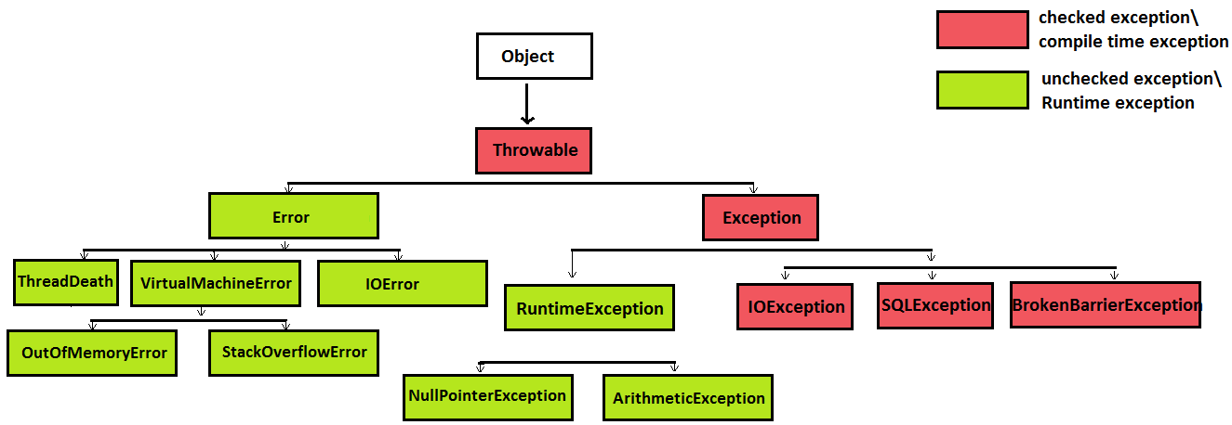

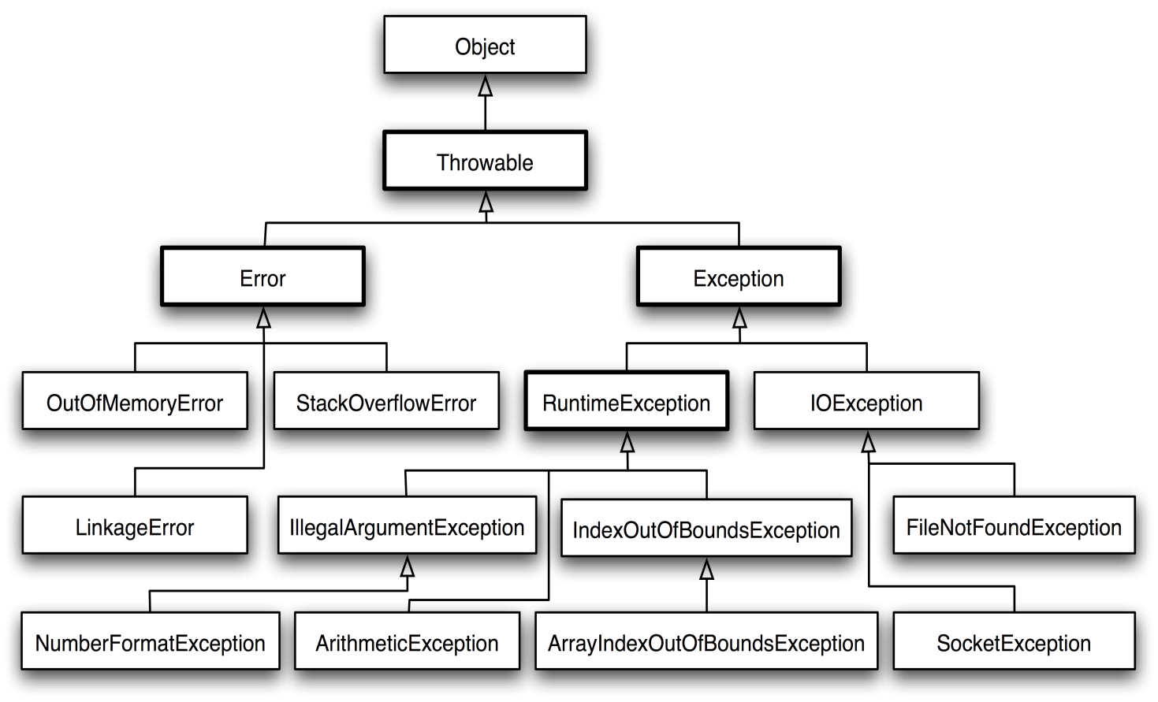

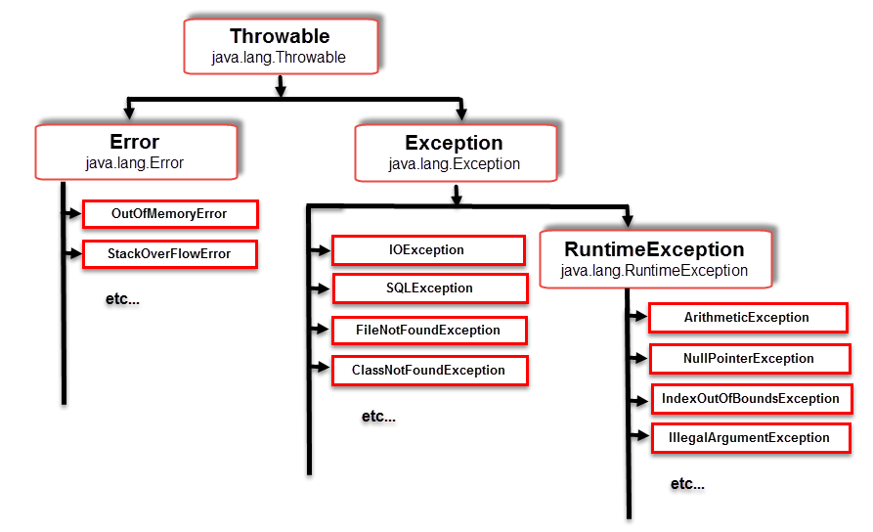

We handle exceptions using try , catch and finally blocks. We use throw and throws in handling the exceptions.

In try block generally we keep **problematic stmts** (stmts which can give compile time or runtime errors). After try block we have to write catch block. If we don’t write catch block it will give compilation error.

if we keep any other stmt b/w try and catch blocks, it will give compilation error.

In catch block , we try to write some userdefined stmts, when exception occur. These stmts are used for logging purpose.

Writing finally block is optional. Generally we use finally block, if we are dealing with file read/write operations or data base operations.

Q) explain the execution flow of try, catch and finally blocks when we return a value from try block and when we write System.exit(); in try block?

* If we write **return** stmt in **try block** and the try block has catch and finally blocks, it executes try block first , when control reaches to return stmt it execute finally block. After that control comes to return stmt in try block and exit the method. If we write **System.exit(2);** in try block, when control reaches this stmt, control will come out of jvm. it will not execute finally block.

In java ,after try block we can write catch or finally blocks. But before catch block, only try block is allowed.

**Throw and Throws:** throw and throws are keywords. Generally throw is used inside a method or constructor.

**Syntax:** throw new <exception-class-name>();

**Ex1:** public void m1(**String s** )throws **Exception**{

If(!s.equals(“string1”)){

//Throw new **Exception**();

Throw new **Exception**(“input is not matched”);

} }

**Ex2:** public void m2(**String s** ){

If(!s.equals(“string1”)){

Throw new **RunTimeException**();

} }

If we compare ex1and ex2, ex1 method m1() (code inside method m1() ) is throwing compilation error, we have to handle at compilation time(from where m1() is called).

Ex2 method m2() (code inside method m2() ) is throwing runtime error, handling these exception is optional.

Generally we use **throw** for user defined exceptions.

In java we use both predefined exceptions(exceptions which are provided by jvm). And user defined exceptions(which are provided by user).

If a piece of code is throwing runtime exception it will not be visible at compile time. Handling runtime exceptions(using try –catch blocks) is not a good practice.

A try block can be followed by one or more catch blocks. So once Exception occur in try block , the catch blocks will be executed sequentially. The catch blocks order is from child exception class to parent exception class. if the order is changed it throws compile time error.

Q) difference b/w throw and throws?

|  |  |
| --- | --- |
| **Throw** | **throws** |
| Throw is used inside a method. | Throws is used at method heading. |
| Syntax: throw new Exception(“Exception”); | Syntax: public void m1() throws Exception, IOException{ //method body  } |
| We can throw exception in constructor. | We can write exception at constructor header level using throws. |
|  |  |
|  |  |

If a method throw any compile time error inside a method, we will write the exception name at method heading level beside throws. Example is

Class A{

Public void m1() throws Exception{

Try{

//method stmts

}catch(IOException e) {

Throw new Exception();

} } }

If we write any stmt after throwing exception(using **throw** key word) inside a method we can not write any other stmt including return. It gives compilation error (unreachable error).

If a method or constructor is throwing exception, where ever we are calling the method or constructor all the places we have to handle by throwing the exception again or using try –catch block.

Static or instance blocks can not throw exception. If static or instance block code is throwing compilation error, we have to handle the exception using try-catch.

**User defined exception:** user defined exception is a normal class, but it should have the below condition.

The class should extend checked(Exception) or unchecked(RuntimeException) exception class.

Class C1 extends Exception{

}

Q) What are the Differences b/w final, finalize,finally?

A) **final** is a keyword and it is used to create constants. **Finally** is a block it is used in Exception scenarios. It means the stmts in finally block will be executed even if exception occur in try or catch blocks. **Finalize** is amethod in Object class and it is used in garbage collection process.

Q) what is marker interface, Why we use it?

A) Marker Interface in java is an empty interface. It means interface does not have constants and methods. It tells the JVM that the class implementing marker interface will have some special behavior. Examples **Cloneable , Serializable.**

**Serializable:** if a class is implementing serializable interface, The serializable interface provides a mechanism of object serialization where an object is represented as a sequence of bytes. Object serialization writes the object intostream.  
  
it means the class can be transfer through FTP(eg: we can write the class into a file and we can read the object from the file )**.**

If we do not implement serializable interface and if we try to write the object to a file, it will throw runtime error(java.io.NotSerializableException**).**

**Cloneable:** if a class implements Cloneable interface, we can create the clone of an object(it means it will create a copy of object ). In order to get the clone of an object, it is required to type casted into its appropriate type. If a class is not implementing the cloneable interface, and we try to clone that object we get a CloneNotSupportedException .

We have to override clone() in our class. When we are calling java.lang.Object.clone() (super.clone ) in the overridden clone(), it may throw checked exception (CloneNotSupportedException).

We have to typecast the clone() to our own class.

Factorial: product of a number from 1 to it self.

5!=5*4*3*2*1

Palindrome: reverse of a number or word(String) equals to the same.

1441,12121,madam,amma.

Armstrong: a number should be equals to the sum of the cube values of the digits.

153= (1*1*1)+(5*5*5)+(3*3*3)

Prime number: prime number is divisible by 1 and it self (not by any other number). Prime numbers starts from 2.

2,3,5,7,11,13,17,19,23,etc..

Fibonacci series: it starts from 0,1. Next digit will be equals to the sum of the 2 left side numbers.

Eg: 0,1,1,2,3,5,8,13,21,34,55 etc…

**Factory method :** it is used to provide objects. In java we have static and instance factory methods.

Q) What is singleton and how can we achieve?

**A) Singleton class:** Singleton is a design pattern it is used to create only one object per jvm. We can achieve singleton with a static factory method and a private constructor.

Q) what is String immutability in java?

A) String immutability means once the value is assign to a String, the value of the memory can not be changed. it means once we assigned a value to String and we can not append another String for the same memory. If we append another String, it will be stored in new memory,but it will not override the existing value.

**String,StringBuffer,StringBuilder :** in java String is immutable. Which means once the value is assign to a String can not append another String for the same memory. If we append another String, it will be stored in new memory.

To over come String immutability StringBuffer,StringBuilder are used.

Q) Difference b/w StringBuffer,StringBuilder?

|  |  |
| --- | --- |
| **StringBuffer** | **StringBuilder** |
| StringBuffer is synchronized i.e. thread safe. It means two threads can't call the methods of StringBuffer simultaneously. | StringBuilder is non-synchronized i.e. not thread safe. It means two threads can call the methods of StringBuilder simultaneously. |
| StringBuffer is less efficient than StringBuilder. | StringBuilder is more efficient than StringBuffer. |

Q) difference b/w .equals()and == operator?

**.equals():**  it verifies Strings value only. It is used to verify 2 objects.

**“==”:** it verifies Strings value and memory.

Q) What is StringTokenizer?

**StringTokenizer:** The **java.util.StringTokenizer** class allows you to break a string into tokens(small Strings). It is simple way to break string. To implement this we will create 2 arg constru1ctor for **StringTokenizer class.**

StringTokenizer stringTokenizer = new StringTokenizer(String s1, String delim)

**Collection Freamework :**

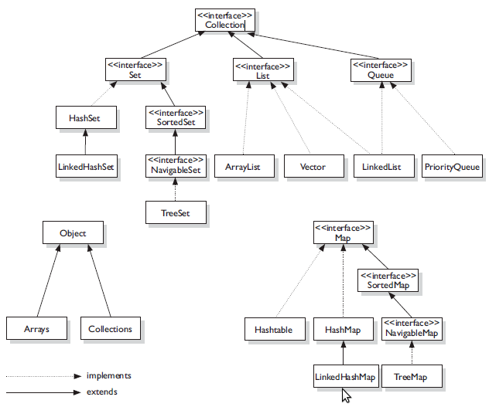

In collections we can store 1-dimention elements and 2-dimentional elements . By looking at the above diagram **Collection** and its hierarchy is used for 1-dimentional elements(starts from index 0) and **Map** and its hierarchy is used for 2-dimentional elements(kay-value pairs).

Collections support heterogeneous data(we can add any type{int, char, float, Boolean, String, wrapper Classes, userdefined classes} of data). To overcome this We can create generic collections from java1.5.

Generic collections will support only Class type data, not Premitives

Collection<int> // wrong. it gives compilation error.

Collection<Integer> // correct

Q) difference b/w List and Set?

|  |  |
| --- | --- |
| **List** | **Set** |
| List allows duplicate values | Set allows unique values |
| List preserves insertion order (it inserts elements in the order we insert. New element will be added at the end). List inserts elements in linear order. | Set does not preserve insertion order(it inserts values in random order following by hash mechanism.) Set inserts elements in random order. |
| We can add any number of null values. add() returns Boolean value(true). | We can add only one null value. If we add more than one null values or duplicate values, it overrides old value with new value . Set add() returns Boolean value (false). |
| List implementations: [ArrayList](http://beginnersbook.com/2013/12/java-arraylist/), Vector,[LinkedList](http://beginnersbook.com/2013/12/linkedlist-in-java-with-example/) | Set implementations: [HashSet](http://beginnersbook.com/2013/12/hashset-class-in-java-with-example/), [LinkedHashSet](http://beginnersbook.com/2013/12/linkedhashset-class-in-java-with-example/), [TreeSet](http://beginnersbook.com/2013/12/treeset-class-in-java-with-example/) etc. |
| Iterator and ListIterator are used to traverse List. Iterator suppots forward direction,  [ListIterator](http://beginnersbook.com/2014/06/listiterator-in-java-with-examples/) can be used to traverse a List in both the directions(forward and backward) | We can use Iterator only to traverse Set. |

Q)how to add, delete, retrieve elements in List?

Q)how to add, delete, retrieve elements in Set?

Q) List and Set are sub interfaces of Collection. but why we do not have get(int index) in Set, why it is present in List?

Q) difference b/w ArrayList and Vector ?

Q) difference b/w ArrayList and LinkedList, when we use these two classes?

Q) difference b/w HashSet and SortedSet? difference b/w HashSet and TreeSet?

Q) difference b/w HashSet and LinkedHashSet?

Q) how many null values we can store in ArrayList,HashSet?

Q) how many null values we can store in TreeSet or SortedSet?

Q) how to add, delete,find elements in List and Set?

Q) what happends if we update or delete an element in List while inserting or retrieving elements?

Q) how HashSet is implemented (or) internal implementation of HashSet (or) how Set will store unique elements

Q) difference ,similarity b/w Collection and Map?

Q)how can insert values in Map why we do not have add() in Map (or) why put() in Map , why not add() ?

Q) difference b/w HashMap and SortedMap?

Q) difference b/w HashMap and LinkedHashMap?

Q) what is java.util.Map.Entry ?

Q) how many null keys and values are allowed in HashMap ,what happens if we add more than one null key or null value?

Q) how many null keys and values are allowed in TreeMap , what happens if we add more than one null key or null value?

Q) how many null keys and values are allowed in HashTable , what happens if we add more than one null key or null value?

Q) in how many ways Map can be iterated?